DISTRICT 6900 INTERACT CLUB
YEAR END REPORT
2014-2015
Interact Club:__Crabapple Middle School _____________________________________________________________

Faculty Advisor: _Mrs. Angelique Hayes & Mr. Glenn Mize_________________________________________________________________________

Sponsoring Rotary Club: ______Roswell ______________________________________________________________________________________________

Rotary Liaison: Mrs. Karen Schwank & Becky Nelson___________________________________________________________________________________

Total # of Activities: ____8___

# of awareness events: ___5____ Cause(s) (example: Polio, Human Trafficking, Clean Water):
- Dr. Scott Moscow spoke to us about Honduras and how he is going to get the 57 eyeglasses we collected ready for someone else to wear AND SEE!
- Senator John Albers spoke to us about HonorAir and sponsoring a Veteran for the flight
- Mr. Steve Oles spoke to us about his mission with the Alpharetta American Legion to send care packages to active duty personnel. So far he has sent over 5,000!
- NOTE before year’s end: We plan on hosting a gentleman to talk about the Clean Water project in Honduras AND be a “Page for a Day” at the State Senate as a guest of Senator John Albers.
- We collected over 300 new toys for Scottish Rite Children’s Hospital. Any used toys donated were delivered to North Fulton Charities.

# of recruiting events: __8_____

# of service activities: ___4____ Average number of hours per member: _______8_______

# of social activities: ___2____

# of fundraising events: ___1____ Total monies raised: $911
For what cause(s)? Sponsor a veteran for the 2015 HonorAir flight

Total # of members: ____18___

# of new members (recruited this year): __17_____

# of returning members (from previous year): ___1____ (majority of last year’s members moved on to high school)

# of graduating members: _______

How does your club promote events? (Select all that apply.)

__x___ Email __x___ Flyers/Posters on campus

__x___ School Activities Calendar _____ School Newspaper

__x___ Word of Mouth __x___ Class Announcements

__x___ Facebook/Instagram/Twitter _____ Electronic Signs at the school

_____ Sandwich Boards _____ Usually students don’t know what’s going on

_____ Usually students find out when walking up on it and discovering something’s going on.

Other: _________________________________________________________________________________________

List one of your club goals that were attained this year. Describe how it was achieved (use additional paper if necessary).
- Create a sustainable and vibrant Interact Club! We elected our leadership from a group of students who really did not know what Interact really was yet! We have held leadership training to help those officers learn how to lead their peers. We decided to have one meeting per month in the morning and one in the afternoon to help those students who could only attend one due to a time conflict. For that reason, we elected co-presidents.
- We wanted to be immediately active, so we adopted fast and easy projects that supported some Roswell Rotary projects already in progess along with a familiar project interact had taken on for the past 2 years.
- Decorated the Youth Day Parade float for the Roswell Rotary
- Collected 57 eyeglasses for Honduras
- Collected items for care packages sent to a Platoon adopted by Roswell Rotary
- Collected over 300 new toys for children in Children’s Healthcare over the holidays… Delivered them in time for Christmas (this was the project we had done in previous years)
- The club decided to adopt a Patriotic 2nd semester…. Sponsor a veteran to go to HonorAir. To raise the $911 dollars needed, we are in the process of selling $20 MIDAS cards for free oil changes.

Other activities to consider:
- Jan 21st we went bowling to celebrate our 2014 success
- We had one or two students attend the Interact Fall Conference and report back to the rest of the club.
- Leadership Training – Because we are working with 6th, 7th and 8th graders, we elected to create a Leadership Training monthly time… The 2nd Weds of each month, we meet with the Presidents, VP, Treasurer, Publicity Chair and Scrapbook Chair and talk about their duties, how they are currently comfortable in their role (or not) and leadership formats that can help them live into their role a bit better. It has worked VERY WELL… We hope that our 7th grade leaders will then become some of our 8th grade leaders and actually start leading every step of each meeting.

President’s Signature: _______________________________________________ Date: __________________

President’s Printed Name: _______________________________________________

Faculty Advisor’s Signature: ______________________________________________ Date: __________________

Faculty Advisor’s Printed Name: _______________________________________________________________________

Pictures representing the year:
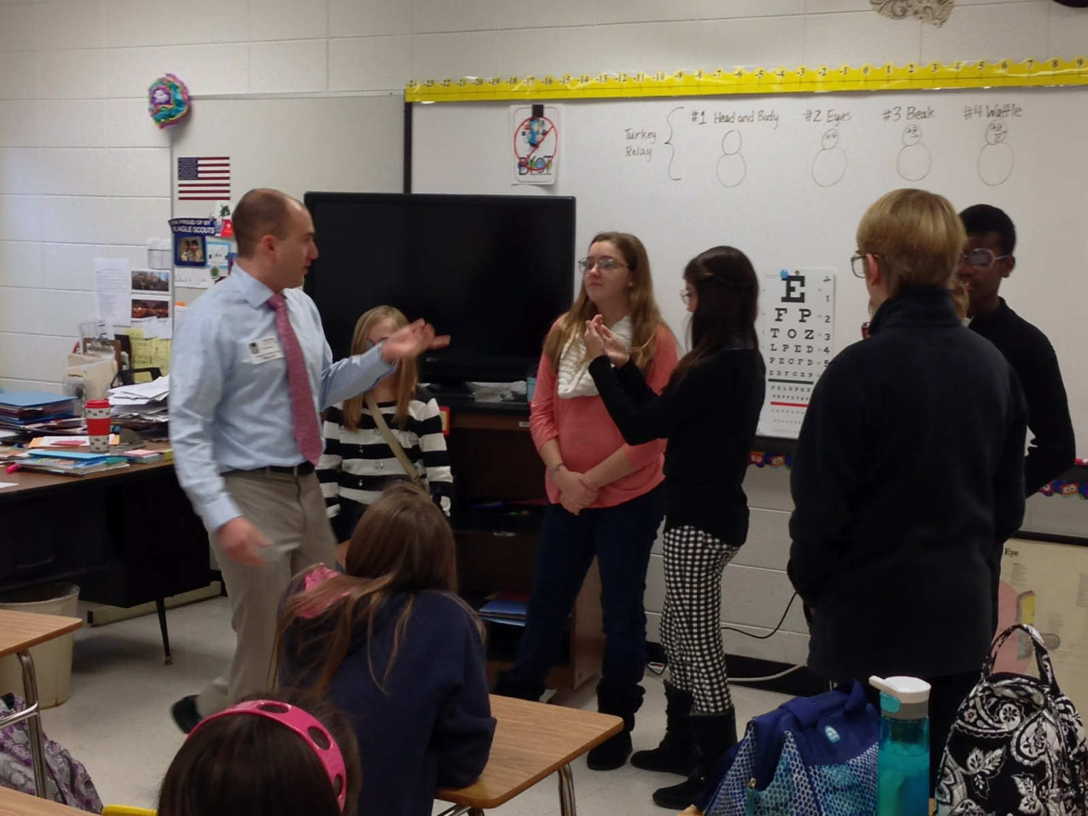
Dr Scott Moscow talking with the kids about eyeglasses and different diagnosis….

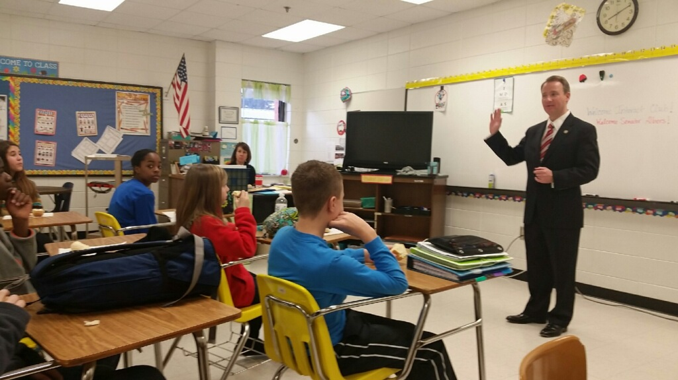

Senator John Albers talking about Patriotism and … HonorAir

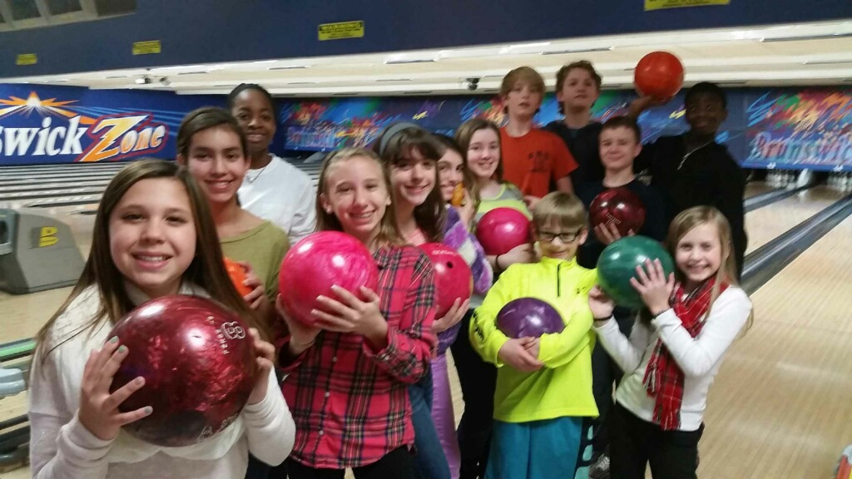

Bowling Party to celebrate successful 2014!

